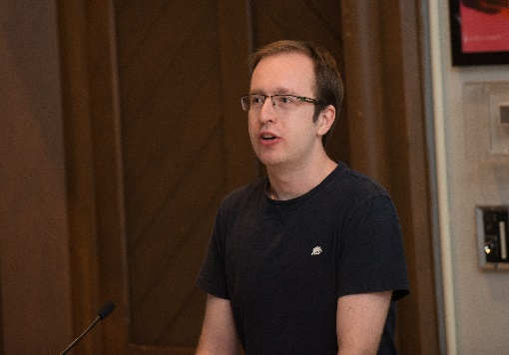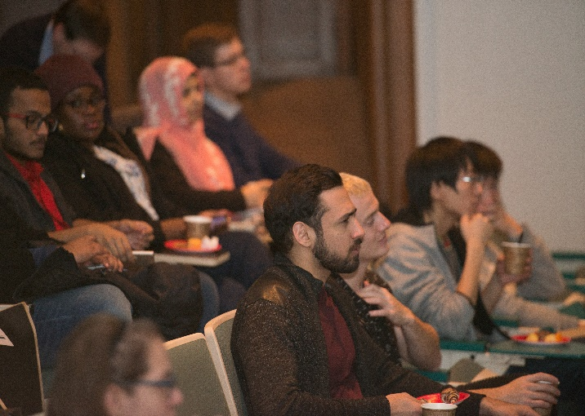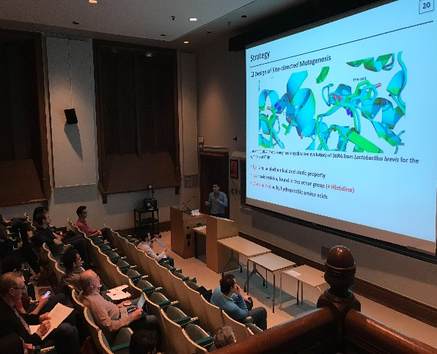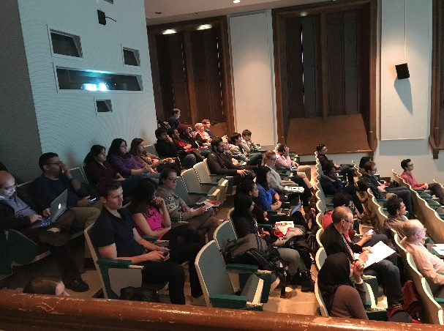

**Eventbrite:   
https://goo.gl/gVjQDw**

**!!!** Monday May 14th 1PM– 5PM **!!!**  
Bahen Centre 1160

Celebrate **research**.  
Share ideas.  
Promote *collaboration*.  
***Have fun***!

Keynote: Engineered bacterial strains to improve gut health through targeting NOD2

*Professor Dana Philpott  
Department of Immunology, University of Toronto*

Also includes: 3 & 15min presentations,   
and poster session. Food provided!